Prestressed Girder Automated LRFD Design

## Single Line Girder Approximation of Demands

Dead load and live load demands are computed the same as they are for steel girder design. If a structure has multiple spans, the demands for dead load are computed with the spans acting individually as simply-supported, and then as a multi-span continuous structure for the superimposed dead load and live load demands. This is due to the assumption that the girders are made continuous after the deck is poured with a cast-in-place connection. While many prestressed, multi-span bridges are not made continuous, for the purposes of this study, they would simply behave as two single span, simply-supported bridges and thus would yield no further information. Therefore, for this study, all multi-span prestressed girder bridges will be considered continuous for live load.

## Member Sizing and Prestressing Design

The automated design software is capable of designing prestressed multi girders for single span bridges or multiple span bridges that are continuous for live load. The software first chooses a standardized section appropriate for the span length. The software can choose from either AASHTO standard I-beams Bulb-Tee standard sections. It will choose the smallest section that is appropriate for the span length as specified by the Prestressed Concrete Committee for Economical Fabrication (PCEF) as seen in the table below.

|  |  |
| --- | --- |
| Section | Max Span (ft) |
| PCBT 29 | 60 |
| PCBT 37 | 80 |
| PCBT 45 | 100 |
| PCBT 53 | 115 |
| PCBT 61 | 125 |
| PCBT 69 | 135 |
| PCBT 77 | 145 |
| PCBT 85 | 150 |
| PCBT 93 | 155 |

The prestressing strands are designed in an iterative approach; whereby the number of strands is increased until all design criteria are met. For each attempt (number of strands) the section properties are computed and the demands induced by the prestressing forces calculated throughout the length of the girder. The sections are designed with 0.6 inch diameter, Grade 270 low-relaxation strands. The girder concrete 28-day compressive strength is first set at 8ksi, and may increase to 9 or 10 ksi, if the section does not pass all constraints even when the maximum number of strands is used. If the section is still unable to pass all constraints, the next largest standard section is selected, and the iterative design process repeated.

When evaluating the sections for design, shear and negative moment are not included constraints since they are highly dependent on the harping or debonding patterns, stirrup placement and other reinforcement design decisions, which are at the discretion of the designer and would only serve to cloud the results of the study and are ultimately beyond the scope of the project. The minimum required shear and negative moment capacities to satisfy design demands are used for subsequent analyses.

**Hierarchy of Member Sizing and Prestressing Design Process**

The process of the automated member-sizing and prestressing design is outlined in Figure XX. The specifications constraining the member-sizing are detailed in Table XX.

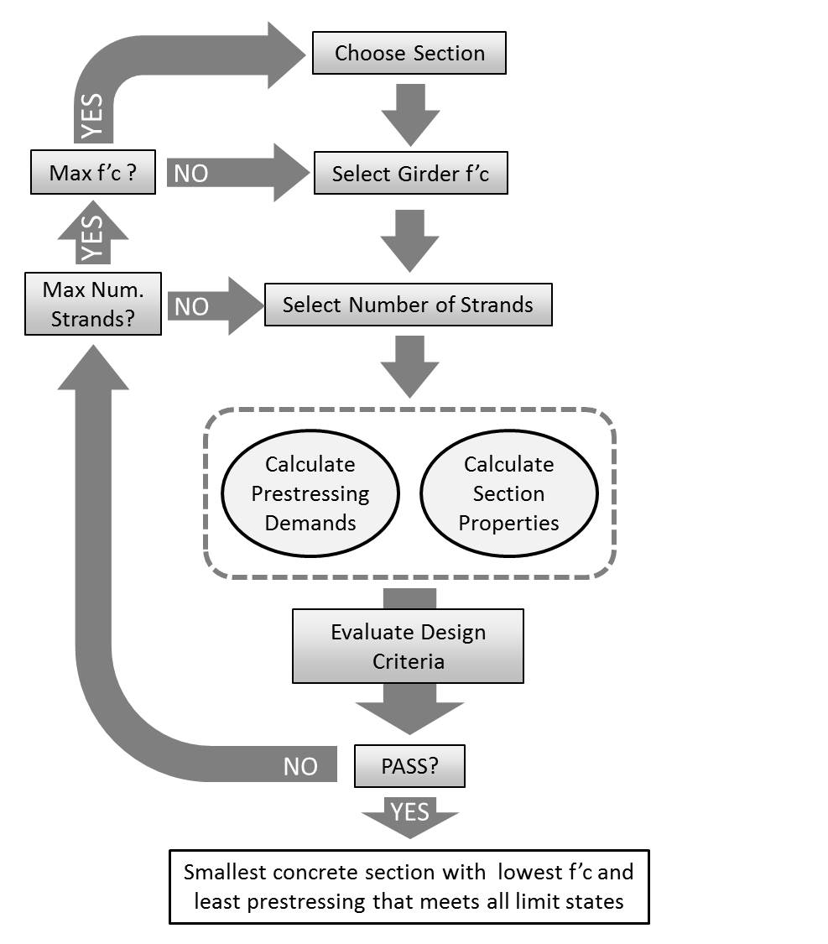

Figure : Automated design of prestressed girders

Table : AASHTO LRFD constraints for multi-girder bridges with prestressed I-beam sections

|  |  |
| --- | --- |
| 1. Stress Limits at Transfer 2. Stress Limits under Service I 3. Stress Limits under Prestressing and DL after Losses | 1. Stress Limits under Service III 2. Deck Stress Limit under Full Load 3. Strength I Limit State 4. Minimum Reinforcement Check $min\left\{\begin{matrix}1.33*M_{u} \\ M_{cr}\end{matrix}\right\}≤φM_{n}$ |